**Buffers and timeouts:**

* Buffer means RAM.
* Timeout means restricting the connections after some particular time. This prevents from client sending endless data and breaking the server.

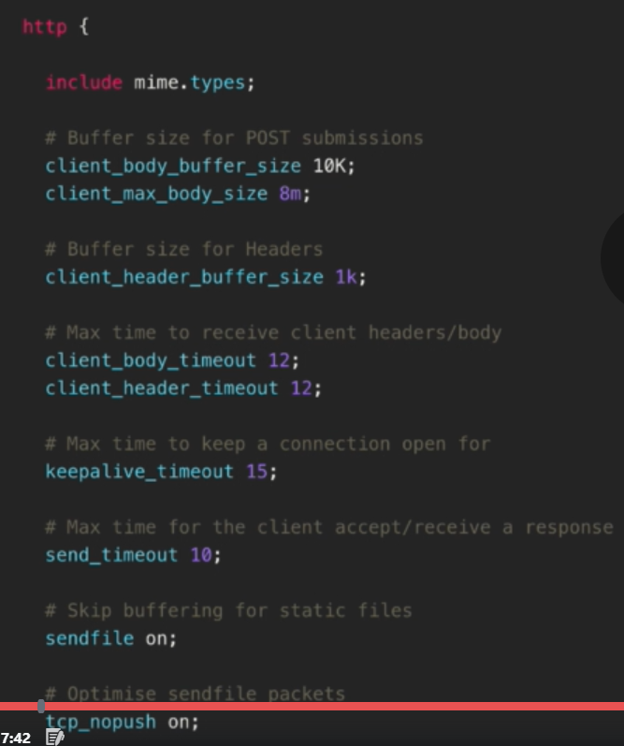

* **“client_body_buffer_size”** is the basic form submission memory. Increasing this memory more than what we need will unnecessarily allocate memory and decrease the performance of the server.
* **“client_max_body_size”** means don’t accept post body request more than 8M. and if it is larger than that, the server will respond with **“413 – request entity too large”** error.
* 8m is good enough for the setup for the images to be uploaded and so on.
* **“client_header_buffer_size”** is memory to reading request headers. 1K is more than enough generally.
* Client receive headers/body set to 12 secs which is good enough.

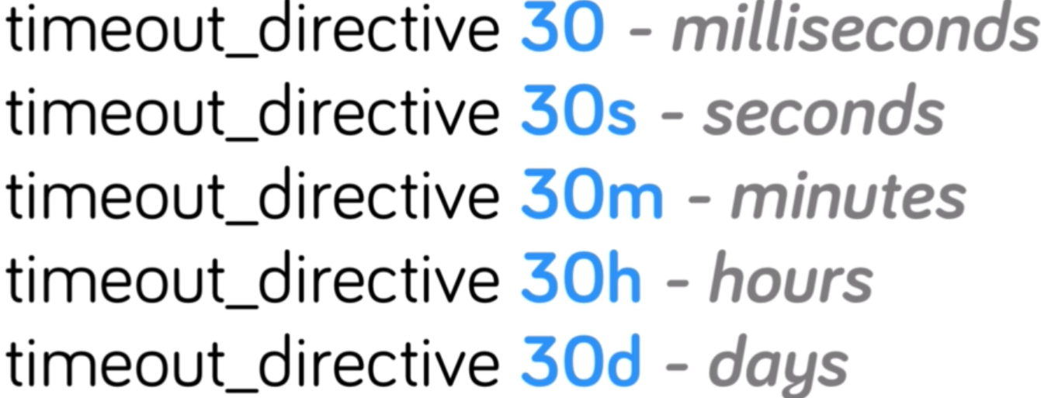

* **“Keepalive_timeout”** is to kill the connection after specific time.
* **“send_timeout”** means if the client does not receive any data after the given data, then it will abort sending the data.
* **“sendfile”** on mean when sending any file to the client, don’t save it or read it from buffer. Directly send it from disk.
* **“tcp_nopush on”** will optimize that data while sending to customer.

**Headers and expires:**

* Let’s say a photo, we can tell the browser to cache that, so that the reload time of photo will be faster next time.